BONE TUMORS
- Benign tumors  - Malignant tumors | - Secondary carcinoma of bone | - Tumor-like conditions of bone
Bone is a mesenchymal tissue. Thus tumors of bone may arise from different tissue components-osseous, e.g bone, cartilage, periosteum and nonosseous, e.g fat,fibrous, tissue, nerve tissue, vasculaar tissue, etc. Indigenous to the bone. | Tumors of bone are commonly benign and metastatic deposits in bone are commoner than primary bone tumors. Of the primary bone malignancies, multi[ple myeloma is the commonest.  Most primary malignant bone tumors occur in child and young adults. | BENIGN TUMORS  Osteoma  - this is a benign tumor composed of sclerotic, well-formed bone protruding from the cortical surface of a bone.
Classification of bone tumors
 | Benign | Malignant
- Bone forming tumor | - osteoma ( from osteoblast)  - osteoblastoma | Osteosarcoma
- Cartilage forming tumors | - Chondroma  - Chondroblastoma (from cartilage cells)  - osteochondroma | Chondrosarcoma
- Giant cell tumor ( GCT) FROM OSTEOCLASTS | - Benign GCT | Malignant gct
- Marrow Tumors |  | - Ewing’s tumor (from reticuloendothelial cells of marrow)  - Multiple myeloma (from plasma cells)  - Malignant lymphoma(NHL-Non Hodgkin lymphoma)
- Vasular tumors | Hemangioma | Angiosarcoma
- Others ( other connective tissue and nerve tissue tumors) | - lipoma  - fibroma  - neurilemmoma( from nerve sheath) | - liposarcoma  - fibrosarcoma  - malignant fibrous histiocytoma  - undifferentiated sarcoma  - neurofibrosarcoma
- Tumor-like lesions | - bone cysts-simple or aneurysmal  - fibrous dysplasia  - reparative giant cell granuloma(e.g. epulis
Types
- Ivory osteoma - arises from the membrane bone of skull.  - Osteoid osteoma- it can arise in any bone except the skull bone, the commonest bones affected are the femur and tibia.  X-ray will confirm the diagnosis. X-ray shows a small round or oral radiolucent area with sclerosis at the margin.  These tumors do not undergo malignant transformation.  Treatment  Excision of the osteoma | Chondroma  This tumor arises from precartilaginous cells of the bone, which fails to become ossified. It usually involves the short long bones viz. Metacarpals, metatarsals and proximal phalanges of hands and feet.  Pathology  It is usually solitary.  Types  They are two types:-  - enchondroma-growing within the bone  - Ecchondroma-fracture is common due to thinning of the cortex.Occasionally chondroma malignant change becoming a chondrosarcoma  Clinical features  - the tumor usually presents with painless expanded swelling of the affected bone.  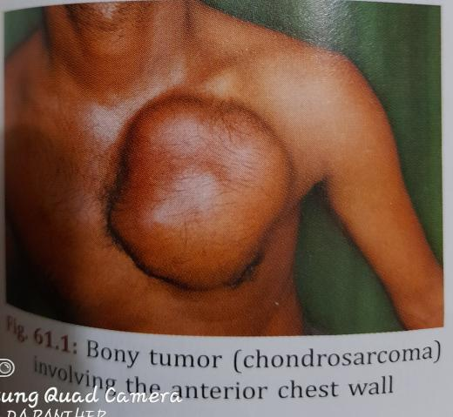  - an ecchondroma may interface with joint and tendon movement.  - the patient may present with a fracture after a trivial injury.  - X-ray shows a rarefied area on the cortex with a clear outline.  Treatment  Excision of the tumor |  | Osteochondroma  ( syn-exostosis)  This tumor consists of normal bone covered by a cap of cartilage. It is one of the most common benign tumors.  It is truly a hamartoma, arising from the growth plate of the developing bone. As the bone grows in length, the tumor gets left behind and thus appears to migrate along the shaft towards its center.  It grows outwards from the bone like a mushroom. The lesion stops growing when the growth of the skeleton ceases.  Clinical features  - Age- usually present in teenage and adult life.  The most common site of osteochondroma is the growing ends of bone includeing the diastal femur, proximal tibia and proximal humerus.  Examination  The tumor is bony hard in consistency and fixed to the bone but not the muscle or skin. X-ray shows mushroom like bony tumor but not the cartilaginous cap.  Treatment  Excision of the tumor if it causes pain or pressure symptoms on the adjacent structures, but one should wait untill the cessation of skeletal growth, I.e after epiphyseal union.
MALIGNANT TUMORS
OSTEOSARCOMA  Excluding multiple myelomas these are the most common primary malignant tumors of bone, derived from the pluripotent mesenchymal cell with bony propensity. | Primary osteosarcoma  There are no known premalignant conditions related to it. It is commoner and occurs in the age group of 10-20 years. It is much more malignant than the secondary one.
Classification  Osteosarcoma has been subclassified as follows.  - Depending on the presence of preexisting lesion- (i) primary osteosarcoma- no pre-existing lesion present.  (ii)secondary osteosarcoma - developing in presence of a pre-exsting lesiom.  2. depending on the dominant histomorphology the following are the subtypes.(a) Osteoblastic osteosarcoma- with alot of new bone formation.  (b) osteolytic type or telangiectatic osteosarcoma- which is predominantly a lytic tumor. Hence pathological fracture is common.  © fibroblastic osteosarcoma, the basic cell being the fibroblast.  (d) chondroblastic osteosarcoma, the basic cell being a cartilage cell. It is common in the pelvis. | Secondary osteosarcoma  This occurs in the older age group(45 years onwards). it arises from preexisting lesion or in bone that has been irradiated.  Pre-existing lesions are paget’s disease, multiple enchondromatosis, fibrous dyspiasia, irradiation, multiple osteochondroma, etc.  Spread  All osteosarcomams are aggressive lesion and metastasize widely through the bloodstream, usually to the lungs. Lymph node involvement is unusual. Osteoblastic type.  Clinical feature  - pain is usually the first symptom. Soon followed by swelling. The pain is constant boring and becomes worse, as the swelling increases in size  - the bones commonly involved in order of frequency are distal femur. Proximal tibia, proximal humerus, pelvis and fibula. Over 70percent of all osteosarcoma as occur in the lower limbs  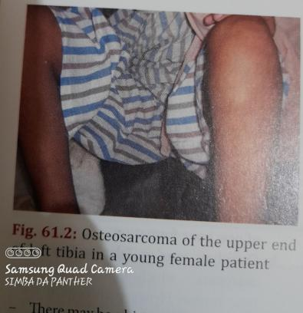  - there may be a history of trauma but more often it is incidental and draws attention of the patient to the swelling. Sometimes the patients presents with a pathological fracture. |  | On examination  The swelling is usually located in the region of metaphysis, firm to soft in feel and highly tender.  Local temperature is raised due to high vascularity and the skin over the swelling is red, tense and glossy with prominent veins on it.  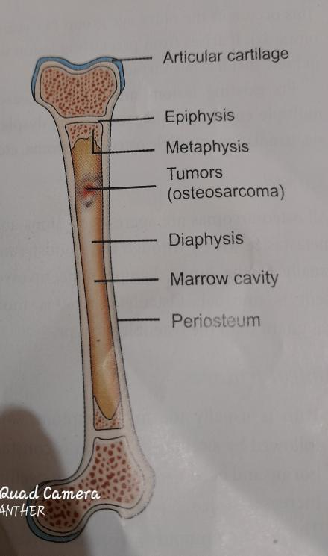  Origin of osteosarcoma from the metaphysis of a long bone. It is to be noted that osteoclastoma is epiphyscal and Ewing’s sarcoma is displayed in origin  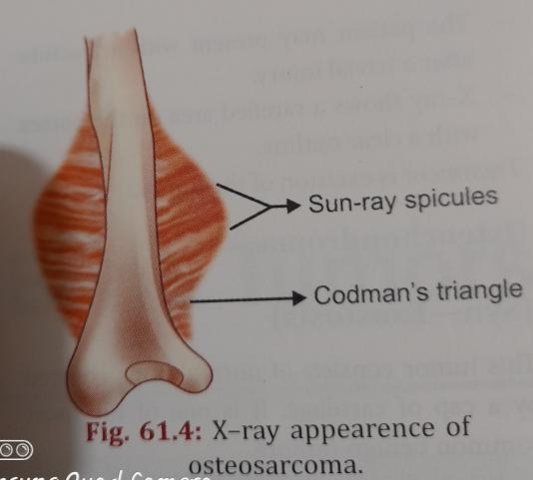
X-ray  - local X-ray shows the following features ( fig.61.4)  - The growth is at the metaphysis.  - Usually but not always there is evidence of new bone formation. Tumor bone is laid below the periosteum especially along the stretched blood vessels and at the junction of bone and lifted periosteum. These are prominent in X-ray plates as sunray spicules and codman’s trioangle respectively.  - There is a big soft tissue shadow.  - X-ray chest- metastasis may be present in the form of multiple deposits or as a solitary cannon ball deposit.  CT SCAN AND MRI  these are important investigation modalities to know the extent of tumor spread within the medullary cavity. The soft tissue involvment is best delineated with the MRI.  BIOPSY  Either a core biopsy or a biopsy is done to confirm the dianosis. Sometimes, the fine needle aspiration cytology ( FNAC), a relatively quicker and easier method may establish the diagnosis.  TREATMENT  The aim of treatment is to confirm the diagnosis from the clinical features, X-ray findings and biopsy, to evaluate the spread of tumor from CT scan and MRI of the affected bone and chest X-ray and to execute adequate treatment.  The different modalities of treatment include:-  - Surgery  - Chemotherapy  - Radiotherapy  - SURGERY  A limb ablation or a limb salvage surgery may be done depending on the spread of the tumor.  - Early presentation of tumor: when the tumor is diagnosed in the early stage neoadjuvant chemotherapy is given to down size the tumor and its vasculariry. Limb salvage surgery is performed subsequently. The bone defect of the excised tumor is filled with bone grafts. Custom made prosthesis or intramedullary nail can also be used depending on the situation.  - Locally advanced tumor: in patients with locally advanced disease, amputation has to be performed with complete removal of the tumor. Pain relief is also obtained with amputation and is an important indication for palliative amputation  - CHEMOTHERAPY  Preoperative neodjuvant chemotherapy decreases the size of the tumor and also ablates the micrometastases that have already occurred.it has made possible the concept of limb salvage surgery.  Drugs that yield best response include methotrexate, endoxan and cisplatin.  - RADIOTHERAPY  This may be indicated in cases where the tumor is surgically inaccessible or patient refuses surgery. | EWING’S SARCOMA  It is one of the most lethal primary malignant bone tumors in the pediatric age group.  The tumor usually involes the diaphysis of long bones as well as flat bones such as scapula and pelvis.  It arises from the stromal cells of the bone marrow be round cells and the spindle cells ( fig. 61.5)  Pathology  - femur is the most common bone involved followed by tibia, fibula, humerus, pelvis, and scapula.  - the tumor is soft and may resemble brain tissue cut surface is grayish white.  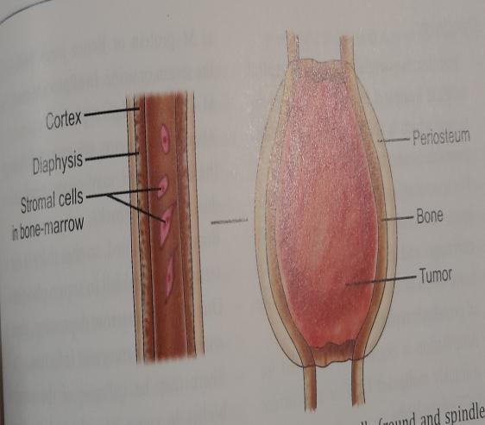  Histologic features are;-  - Undifferentiated round cells in sheets  - There are hyperchromatic cells with scanty cytoplasm. So this tumor is called round cell tumor.  There is alternate deposition of tumors appearance, best appreciated in X-ray.  - spread- hematogenous spread to lungs and other bones is very quick and more common than in osteosarcoma.  - prognosis is worse- if untreated, death is usually within 2 years.  Clinical features  Age - 5-15 years.  Sex - it is more common in males.  This is pain and swelling in relation to the affected bone, associated with local heat and tenderness.  This may be accompanied by fever and malaise so that osteomyelitis is suspected. Moreover, incision on the swelling , based on this diagnosis often brings out semisolid gray material looking like pus and this further confuses the diagnosis.  Thus, as for all bone tumors, the importance of jointly considering the clinical , radiological and pathological evidence cannot be overemphasized.  Investigations  - Local X-ray shows:  - Onion peels appearance due to alternate layers of reactive new bone formation and the tumor tissue.  - Extensive destruction of the bone as shown by widening of the medulla as well as gross rarefaction of the cortex.  - Tissue diagnosis is obtained by needle or open biopsy.  - MRI scanning is very useful to determine the extent of intramedullary and soft tissue involvement and aids in surgical planning.  - X-ray chest and CT scan of abdomen and chest are additional imaging studies to determine metastasis.  Treatment  There are three modalities of treatment:  - Radiotherapy  - Chemotherapy  - Surgery  Ewing’s sarcoma is a highly radiosensitive tumor. In most cases, distant metastasis has occurred by the time diagnosis is made.  Thus treatment consists of:-  - Control of the local tumor by radiotherapy (6000rads) and control of the metastasis by chemotherapy.  - The chemotherapy consists of VAC or vincristine , adramycin and cyclophosphamide in cycles repeated every 2 to 4 weeks for about 12 to 18 cycles.  After radiotherapy, the tumor is excised and the gap is filled with bone and the segments are supported with plate and screws or nail.  Amputation is done in selected cases only. |  | Osteoclastoma(syn-Giant cell Tumor, Gct)  These neoplasms probably arise from the mesenchmal stromal cell and may be benign , locally malignant or malignant. Malignancy may be a transformation of benign tumor or it may arise de novo.  this tumor is called osteoclasoma becouse of he presence of multinucleate giant cells in the tumor which resemble osteoclasts.  Pathology  Giant cell tumor is a neoplasm found maily in the epiphysis of long bones most commonly at the lower end of femur. Other flat bones like ribs, scapula, mandible, etc. And fibula, lower end of radious may also be involved.  Grossly, the lesion is soft gray to red and hemorrhagic in appearance and produces thinning and expansion of the cortical bone. These are bony trabeculae, passing through the soft tumor mass. On the X-ray these give a ‘soap bubble appearance’ which though diagnostic of osteoclastoma is not necessarily a constant feature.  Microscopiccally two types of cells are found viz.  - Spindle cells- these are basic mononuclear stromal cells, the exact nature of which is still unknown.  - Giant cells of foreign body type- these are either products of basic mononuclear cells, or derived from osteoclasts or modified megakaryocytes.  Clinical features  Age- 20 to 40 years.  Sex-it is more common in females. ( fig 61.1)  - swelling is usually located at the end of long bone gradually increasing in size and duration may be more than a year.  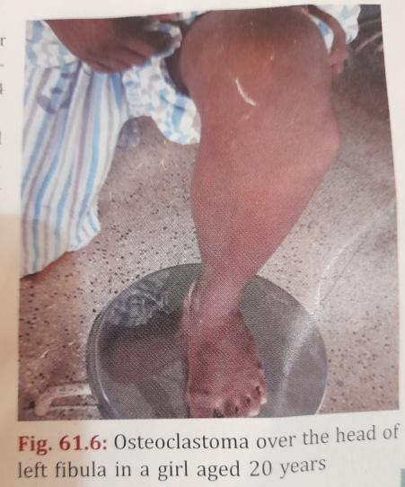  - pain at the site of lesion is not unbearable and is much less than that of osteosarcoma.  On examination  - Surface is smooth, skin temperature not raised and usually there is ni venous prominence over the swelling.  - Tenderness-mild  - Pathological fracture of the affected bone is common as the cortex gets thinned out.  - Joint involvement is mor as the tumor arises from the epiphysis.  Features of the malignant variety are akin to those of osteosarcoma.  Investigations  - Local - X-rays shows the following features:(fig.61.70  - It occures at the end of a long bone and is usually eccentric in situation.  - The long axis of the tumor is long the transverse axis of the bone.  - There is destruction of the bone substance so that the cortex is expanded and thinned out over the tumor.  - There is often a ‘soap bubble appearance’ due to the presence of trabeculae of the remnants of bone transversing the tumor.  - Biopsy- this must be done in all cases to confirm the dianosis. Fine needle aspiration cytology (FNAC) may show the multinucleated giant cells.  - X-ray chest - to detect any metastasis.  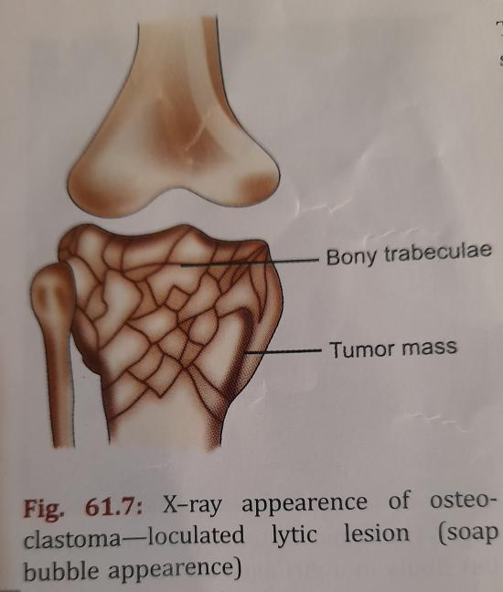
Treatment  - treatment is essentially surgical. The ideal surgical treatment is total excision of the tumor which is readily applicable to dispensable bones like the fibula or ribs.  - for lesions at juxtaarticular sits,e.g. knee joint, the choice rests between through curettage and filling of the cavity with bone chips or the more major procedure of prosthetic replacement.  - amputation is occasionally required for a frankly malignant GCT or a recurrent GCT of the limbs.  - radiotherapy has been tried for lesions either nonoperable or at inaccessible sites such as spinal GCT.  MULTIPLE MYELOMA  multiple myeloma is the most common primary maliganant neoplasm of bone in the older age group > 50 years.  The tumor arises from the plasma cells present in the bone marrow. Hence it is also known as plasmacytoma when it occurs as a solitary lesion, it is known as solitary plasma cytoma, and when multiple, it is known as multiple myeloma(fig. 61.8).  Pathology  Grossly, the tumor is soft, gray and friable.  The bone is simply replaced by tumor and there is no reactive new bone formation.  Microscopically, there is dull monotony of plasma cells and intercellular matrix is little or nil.  Spread  There is hematogenous spread to lungs, liver, spleen and other bones.  Pathologic physiology  - there is hyperpoteninemia, with an increase in the globular fraction, kown as M-protein or Bence jines protein in the serum or urine. In 60percent cases, the M-protein is 1gG type.  - abnormal proteins are excreted through the kidney and may cause renal failure due to tubular block.  - bone is decalcified, so that there is rise of serum Ca⁺⁺and fall in serum phosphate.  - due to bone marrow depression, there is anemia and intercurrent infection.  -there may be collapse of the vertebral bodies to cause neurological manifestations,e.g. paraplegia.  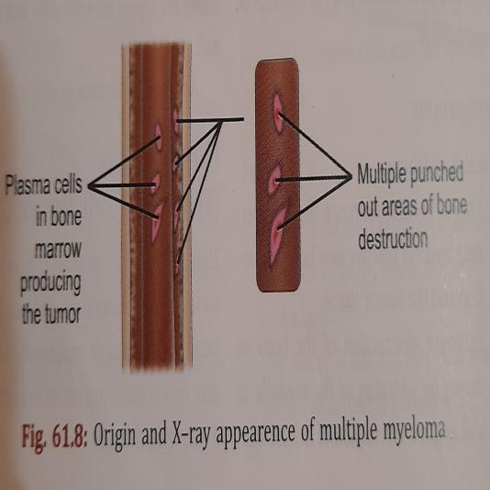 | Clinical features  -age - 50years or more.  -sex- it is more common in men than in women.  - the common presentation is increasingly severe pain in the lumbar and thoracic spine.  -there may be general weakness, anemia and infection.  - Occasionally patological fracture occurs and presents with a deformity.  Renal failure.  Investigation  - Local X-ray - multiple punched out areas of destruction in the skull and other flat bones(fig.61.8)  - Other tests to support the diagnosis of multiple myeloma are:-  - Urine- bence jones proteins are found in 30percent cases.  - Blood- low hemoglobin with very high ESR,increased total protein and Albumin/Globin ratio is reversed. Increased serum calcium and serum alkaline phosphatase is characteristically normal.  - Open biopsy- and open biopsy from the leison may sometimes be required to confirm the diagnosis.  Treatment  - the main modality of treatment is chemotherapy and the drug of choice is melphalan. Other drugs used are vincristine,prednisolone and cyclophosphamide. The treatment cycles are repeated every 4weeks for 6 to 12 cycles.  - radiotherapy in addition to chemotherapy is given to relieve pain.  -complication like pathological fracture is prevented by splinting the affected part. In case of pathological fracture, surgical fixation may be advised.  -antibiotics are given to control infection.  -blood transfusion and hematinics are given to correct anemia.
SECONDARY CARCINOMA OF BONE  Secondary metastasis account for the majoriry of malignant bone tumors and far more common than primary malignant tumors of bone.  The sources are from primary malignant tumors with affinity to metastasize to bone, eg. Carcinoma of breast, prostate, lung, kidney and thyroid.  In some cases no primary site can be found at the time when the secondary lesion presents.  Types of bone lesion  The majority is osteolytic but a few, mostly arising from the prostate stimulate new bone formation and are then called osteosclerotic.  Routes of spread  - Most commonly metastasis occurs through hematogenous spread.  - There is a direct communication between the pelvic venous plexus and the vertebral veins. So carcinoma from pelvic organs may directly reach the pelvic bones and vertebrae.  - Tumors of the oral cavity may involve the jaw bones and those of the rectum may involve the sacrum by direct contiguity.  - In thyroid cancer, whatever is the histological type of the primary tumor, the metastatic lesion is always of the follicular variety. | Sites Of Affection  - Bones rich in red marrow are commonly affected, e.g. vertebrae, skull, pelvis, sternum, ribs, upper end of femur and humerus.  - Unusual sites are below elbow and knees. If there is such lesion, possibility of multiple myeloma should be excluded.  Clinical features  - pain, swelling and often a pathological fracture are the usual presenting features.  - a vertebral metastasis may present with back pain, compression fracture, root pain or paraplegia.  Investigations  - Local X-ray.  - Biopsy in doubtful cases.  - Bone scan with radioactive isotope. It is the optimal investigation for bone pain and detection of early lesions.  - All investigations are done to detect the primary tumor. The breast, prostate, kidney, bronchus and thyroid should be especially investigated.  Treatment  - Curative: this is out of question excepting when the primary growth is suitable for radical surgery and there is a solitary bone metastasis, e.g. hypernephroma, thyroid carcinoma, etc.  - Palliative  - Drugs  - Analgesics- are given for relief of pain. Habit forming drugs are avoided as far as possible.  - Chemotherapy- combination chemotherapy is preffered. Hypercalcemia of malignancy requirs rehydration and IV bi phosphonate therapy.  - Endocrine treatment, e.g. in case of orostate cancer.  - Radiation: it is one of the best ways of palliation. External beam radiation is the treatment of choice for localized bone pain.  - Surgery: the role of surgery is limited. A fungating growth from a bone may require amputation. For pathological fractures, internal fixation provides good results. |  | TUMOR-LIKE CONDITIONS OF BONE  SIMPLE BONE CYST  it occurs in children and adolescents. The ends of the long bones are the favourable sites, the commonest site beign the upper end of the humerus.  The cyst itself may not produce symptoms and the patint often presents with a pathological fracture through the cyst.  X-ray shows a well-defined radiolucent zone in the metaphysis or diaphysis plate is considere ‘active as against the one away from it e.g. in the diaphysis.  Treatment  it is treated with currettage and bone grafting in selected cases.  Asymptomatic bone cysts need no treatment.  Aneurysmall bone cyst.  It is an expansile lytic lesion usually occurring before the age of 20 years. It consists of a blood filled space enclosed, in a shell, ballooning up the overlying cortex - hence its name.  A gradually increasing swelling is the usual presentation. There may be mild pain often it presents with a pathological fractures.  X-ray shows the following features.  1. eccentric well-defined radiolucent area at the ends of long bones and dorsolumbar spines.  2. Expansion of the overlying cortex.  3. Trabeculation within the substance of the tumor.  Treatment is by currettage and bone grafting. In some cases surgical intervation is needed for the treatment of pathological fracture.
FIBROUS DYSPLASIA  This is a disorder in which normal bone is replaced by fibrous tissue-hence the name.  The mass of fibrous tissue thus formed grows inside the bone and erodes the cortices of the bone from within  TYPES  - MONOSTOTIC- only single bone involvement is see. This form affects the femur,tibia,ribs or the craniofacial bones. Children in 5 to 15 years of age are commonly affected. Pain, deformity or fractures are the usual presenting features. | - POLYSTOTIC- multiple bone involvement is seen in this variety. This type of presentation is seen with with precocious puberty(Albright’s syndrome) and other endocrine disorders such as acromegaly, Thyrotoxicosis or cushing’s syndrome. |  | Craniofacial bones are almost always involved in this form.  X-ray will show sharply defined, centrally placed lylic areas with homogenous ground glass appearance. Diagnosis is confirmed by biopsy.  Treatment  The fibrous defect is thoroughly curetted out and the gap is filled with bone grafts.

